1. ECA / Wolfram rule 184 is known as the ’traffic rule’. Implement it; use periodic boundary conditions. Explain in what way it models bottleneck-free congestion by looking at its state transition table.

111 -> 0

110 -> 1

101 -> 0

100 -> 0

011 -> 1

010 -> 0

001 -> 1

000 -> 0

If there is no car in the front the car will keep moving. All cars are moving in their own lane which means there are no traffic jams.

1. Show the evolution of a CA of size N = 50 cells for 50 time steps for the ’car’ densities 0.4 and 0.9. Describe briefly what you see.

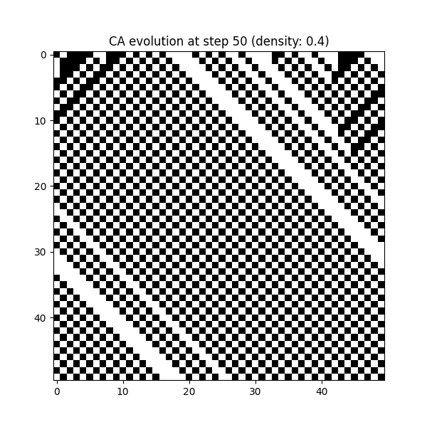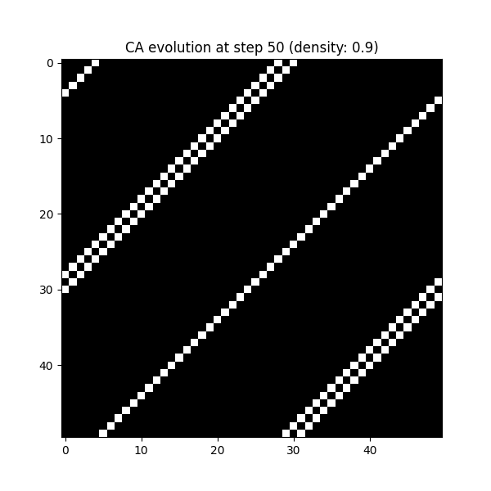

At density 0.4 the cars keep moving consistently. At density 0.9 the cars come to a stop at certain points and that is the phase transition.

1. These are two simulated experiments, or simulations in short, namely the experiment of letting a given density of cars drive on a stretch of road. Name as many advantages as you can think of for simulating these experiments as opposed to using real cars, drivers, and roads.

* No costs of real-world problems like a road, fuel, drivers
* You do not need to get dozens of cars.
* Simulation takes much less time than doing this in real life.
* Parameters of the simulations can be changed with ease.
* Experiments can be repeated many times.
* The data is automatically counted by the code.

1. Write a function which calculates a ’car flow’ value for a given initial state for the CA. We will define it as the number of 1s (’cars’) that cross your system boundary on the right-hand side, per unit time. This represents a measurement that we can compute on a (simulated) experiment. Use a sufficiently large number of time steps, denoted T , to measure this reliably, e.g., T ≥ 1000. Pick any N ≥ 50. Plot this car flow as function of the initial density of cars, using at least 20 density values in the range [0.0, 1.0]. For each density value you should generate multiple initial states and plot average the car flow for each initial state. Let us denote the number of initial states that you sample and average over by R. Is there a clear phase transition, and if so, at which density value?

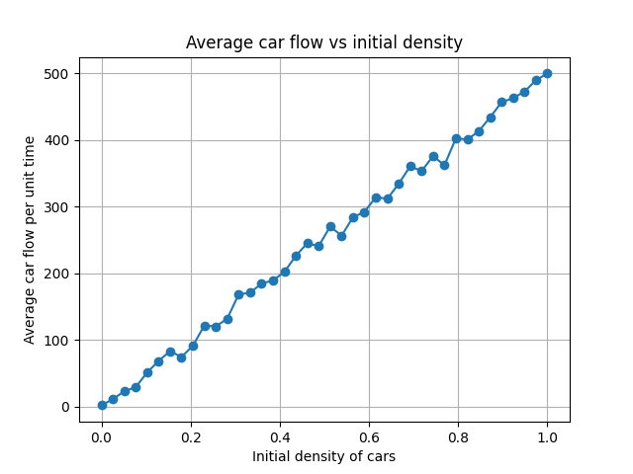Done with t=1000, n=50, r=10, and 40 densities

As you can see there is not a clear phase transition. On average the car flow per time is impacted by the t. The more lanes, the more cars can pass and they will keep going once the first car is on he edge.

“For each density value you should generate multiple initial states and plot average the car flow for each initial state.” This is unclear of what exactly is expected.

1. Now plot the same graph but for a very low T (e.g., T = 5) and a very low number of initial conditions R per density value (e.g., R = 3). What is the effect of such ’undersampling’? Show a plot with undersampled results.

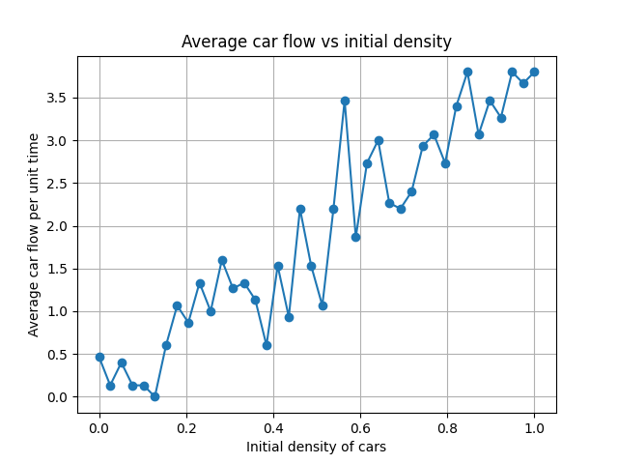Done with t=5, n=50, r=3, and 40 densities

Of course, the graph is very volatile and every average point seems like an anomaly. You could also not determine anything from this.

1. This effect is very important to consider both in real experiments as well as in simulations. Generally it is unknown how many cells or how many time steps are needed in order to have a reliable measurement. In real experiments it is difficult to be sure that we had a sufficient number of cars driving for a sufficient amount of time: human drivers just want to go home at some point, so you’ll have to make due with the data that you gathered – undersampled or not. But in simulation we can measure this. Implement a function which takes the ”car flow versus density” data points1 of exercise 4 as input and returns an automatically estimated ’position’ (density value) of the phase transition as output (termed ’critical density’, a scalar). (Note: the returned value does not have to be equal to one of the input densities, i.e., it may be interpolated.) Mention briefly how you implemented this. At which value for T = Tmin do we have at least 90% probability of inferring the correct critical density? Estimate this probability by repeating your automatic detection many (at least 10) times for each T. The fraction of ’correct’ values is then the probability of inferring the correct critical density. We’ll say that a returned critical density value is ’correct’ if it is within 0.05 of the real value. For each density value use R = 10 and keep it fixed. Show a plot of ”probability correct” as function of T from which it is easy to estimate Tmin by visual inspection.
2. Now it is time to analyze the simulation results, regarding the phenomenon that we started with. Let us say that our minimal model captures the basic phenomenon very well (namely, the existence of a phase transition), using only minimal ingredients (collision avoidance). What can we conclude about the importance of other possible ingredients, such as the gender of drivers or the sizes of their cars, for explaining the existence of the phase transition? Explain why.

For phase transition we also must take into account that cars and their driver will be different. Collision avoidance isn’t the only reason for the phase transition. Heavier cars take longer to stop and are also probably slower at accelerating. Vehicles have different lengths. Drivers have different risk tolerance and reaction times. All these things are not included in the simulation and contribute to the phase transition and frequency of it.